Matt Rumschlag

SD2650

5/20/2015

Lab 5.1

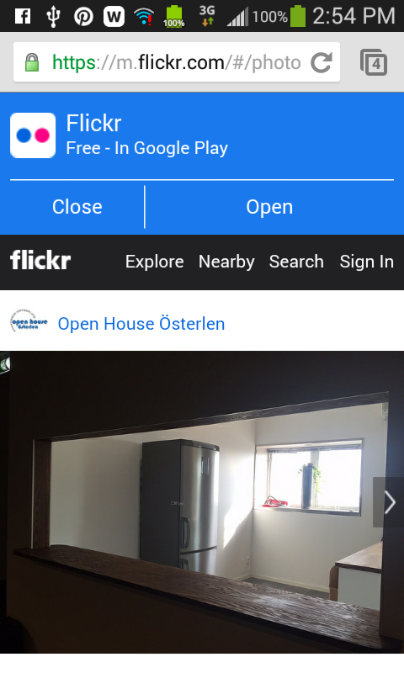

Question 1:

Enabling Javascript can expose vulnerabilities to the system.

Question 2:

Overriding the method to return false means the WebView should load the Url. If it is set to true, then it means that the WebView will ignore the Url.





Question 3:

The page is reloaded.

